**CSC – 575 (Assignment -1)**

Question1:

Question2:

Question3:

For purpose of answering the question, I have selected the GTA San Andreas (Theme Song) - <https://www.youtube.com/watch?v=W4VTq0sa9yg>

Part -1

Time Scales – Short, Middle and Long Term

Dimensions – Timber, Orchestration, Acoustics, Rhythm, Melody, Harmony and Structure.

The opening of the music starts with Chimes followed by repetitive drum beats and piano.

**Rhythm** – The music has a time scale – Middle Term, where a sound is being repeating multiple times. The entire Sequence is coming back again.

**Melody** – The music after the initial opening has a middle term melody repetition, that is high and low drum beats.

**Timber** – There is a lot of classification in Timber (Short term) when the opening comes from the Chimes.

**Structure** – When seen for the long term the music has a lot of time scale differences.

Part – 2

**Casual Users –** Since casual users like listening and collecting music their request will be like (Finding the song that sounds like this) (I like this one, what other songs I may like)(I have to organize my collection)

**Professional Users –**  They may be using music in advertisement and production, they need music for an application, their request information will be like (Given a rhythm give me the music that matches it) (I need this kind of soundtrack with this instrument)

**Music Scholars –** These kinds of people and interested in studying music, developing music (analysis of music tools)(I don’t want the music but the pitch it was sung in)

Part – 3

**Query By humming** – Humming is a way where in a casual user will use a combination of whistling and singing to produce a melody. Then that melody will be used to search/query the sound/music database to find the full version of the song/music corresponding to the melody.

**Query by Example –**  When a part of the music/example of the music is used to query the database to retrieve the full music it is termed as query by example. This will avoid mismatching of the retrieved music.

Part- 4

**Music XML**- This is a type of music representation which used XML as portable format for exchange of information. The best part is the industry wide support including the open-source and commercial projects. Since we can write XML in Latex so we can represent this using the latex.

**MIDI**- it stands for Musical Instrument Digital Interface. This is format where we do the data exchange within digital instruments. This requires sequential information transfers. SMF-Standard Midi File will be used for the future information transfer.

Part-5

Since this entire document deals with MIR and we are doing MIR for the end users, for me that’s the best part of explaining various users that uses MIR. There are three levels of users starting from the most basic going to the most complex ones. The casual users are the one who need music for fun and hobbits. The second level is for the professional student that may need music for their professional purposes, they are commercial users of music. The music scholars are most advanced users; they are one who study music and its composition. It also includes musicians.

Part-6

Question4:

Part - 1

Additive Synthesis Instrument: The actual concept is to have n number of sin wave generator using the defined frequency and helper function – Mixture ()

Code:

**import** numpy **as** np  
**import** matplotlib.pyplot **as** plt  
**import** math  
**import** mir  
**from** mir **import** Sinusoid  
**from** mir **import** Signal  
**from** mir **import** Mixture  
  
*#Declare the frequency and amplitude array*freq = [100,200,300,400,500]  
amp = [10,20,30,40,50]  
*#Declare the empty list*list = []  
*#Making a list of all 5 sinusoids***for** n **in** range (5):  
 sin = Sinusoid(amp=amp[n], freq=freq[n])  
 list.append(sin)  
*#Making a mixture using the helper function in mir.py*mix = Mixture(*list)  
*#Plot the mixture of all 5 waves*mix.plot()

Plot:

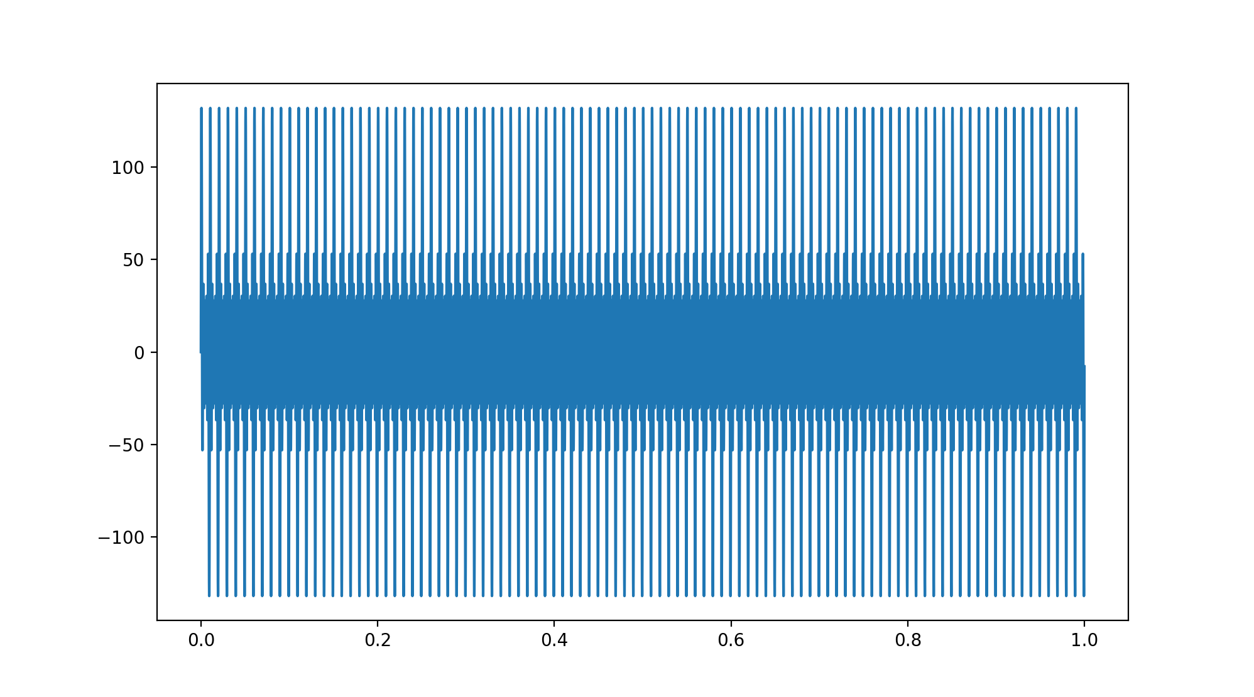

Part - 2

Different Sounds of Same Pitch – passing them to additive Instrument.

Sound 1 = Flute D Tone

Sound 2 = Violin D Tone

Spectrum Analysis Sound 1

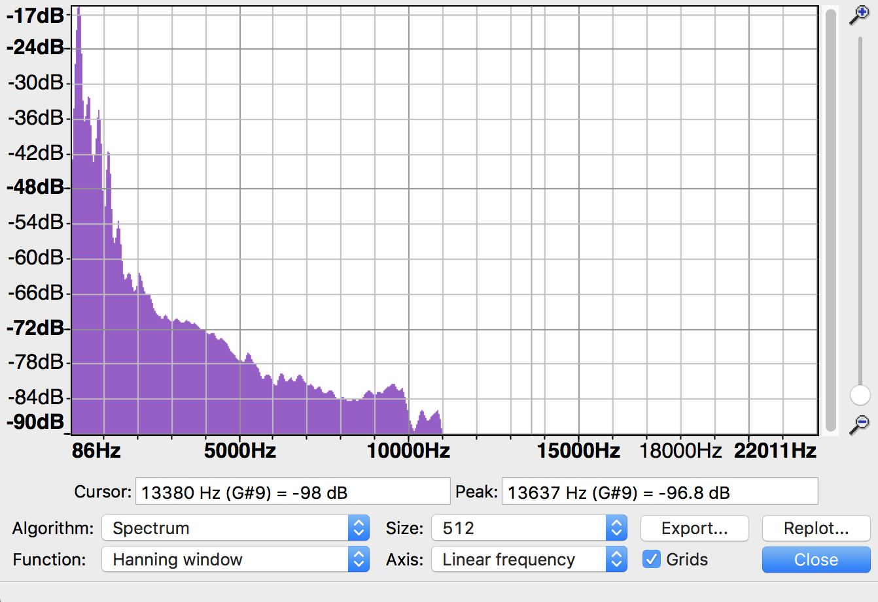

freq = [292,563,869,1160,1439,1767,2064,2828,3159,3447]  
amp = [0.15488166189124816,0.03162277660168379,0.019275249131909367,0.008511380382023767,0.0023173946499684774,0.0007328245331389037,0.0007673614893618193,0.0003388441561392024,0.00031988951096913973,0.00030549211132155157]

Spectrum Analysis Sound 2

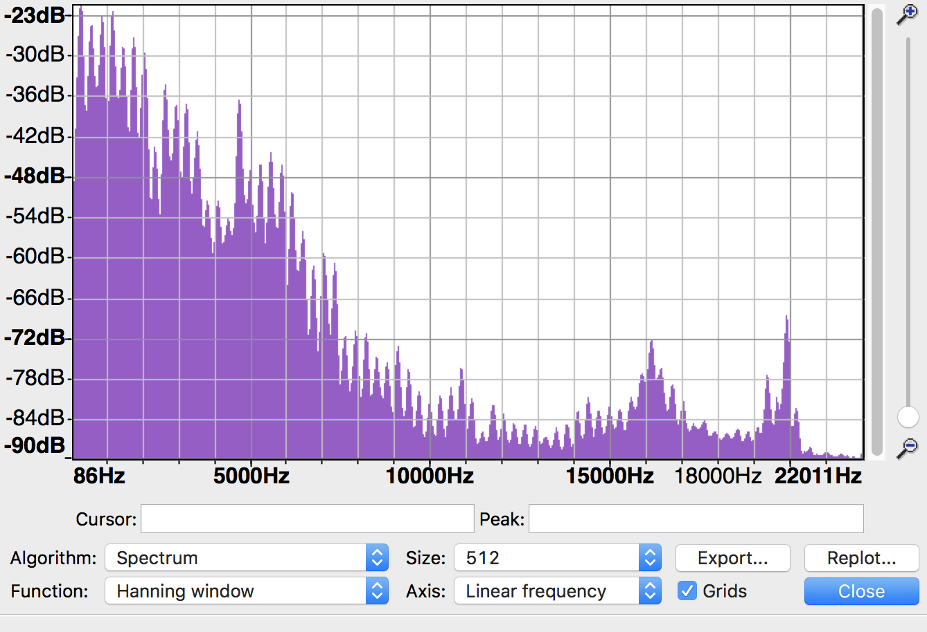

freq = [295,572,882,1165,1460,1764,2052,2343,2633,2931]  
amp = [0.0812830516164099,0.06165950018614822,0.06095368972401691,0.07852356346100718,0.03890451449942807,0.042169650342858224,0.033884415613920256,0.006760829753919818,0.022130947096056376,0.01428893958511103]

Code:

**import** numpy **as** np  
**import** matplotlib.pyplot **as** plt  
**import** math  
**import** mir  
**from** mir **import** Sinusoid  
**from** mir **import** Signal  
**from** mir **import** Mixture  
  
*#Frequency and Amplitude for Sound 1*freq = [292,563,869,1160,1439,1767,2064,2828,3159,3447]  
amp = [0.15488166189124816,0.03162277660168379,0.019275249131909367,0.008511380382023767,0.0023173946499684774,0.0007328245331389037,0.0007673614893618193,0.0003388441561392024,0.00031988951096913973,0.00030549211132155157]  
  
list = []  
**for** n **in** range (10):  
 sin = Sinusoid(amp=amp[n], freq=freq[n])  
 list.append(sin)  
*#make signal mixture*mix1 = Mixture(*list)  
  
sig1 = Signal(data=mix1.data)  
*#output new audio file*sig1.wav_write(**'flu_new.wav'**,normalize=False)  
  
mix1.plot()  
*#Frequency and Amplitude for Sound 2*freq = [295,572,882,1165,1460,1764,2052,2343,2633,2931]  
amp = [0.0812830516164099,0.06165950018614822,0.06095368972401691,0.07852356346100718,0.03890451449942807,0.042169650342858224  
 ,0.033884415613920256,0.006760829753919818,0.022130947096056376,0.01428893958511103]  
  
list1 = []  
**for** n **in** range (10):  
 sin = Sinusoid(amp=amp[n], freq=freq[n])  
 list1.append(sin)  
*#make signal mixture*mix2 = Mixture(*list1)  
  
sig2 = Signal(data=mix2.data)  
*#output new audio file*sig2.wav_write(**'voi_new.wav'**,normalize=False)  
  
mix2.plot()

Plot :

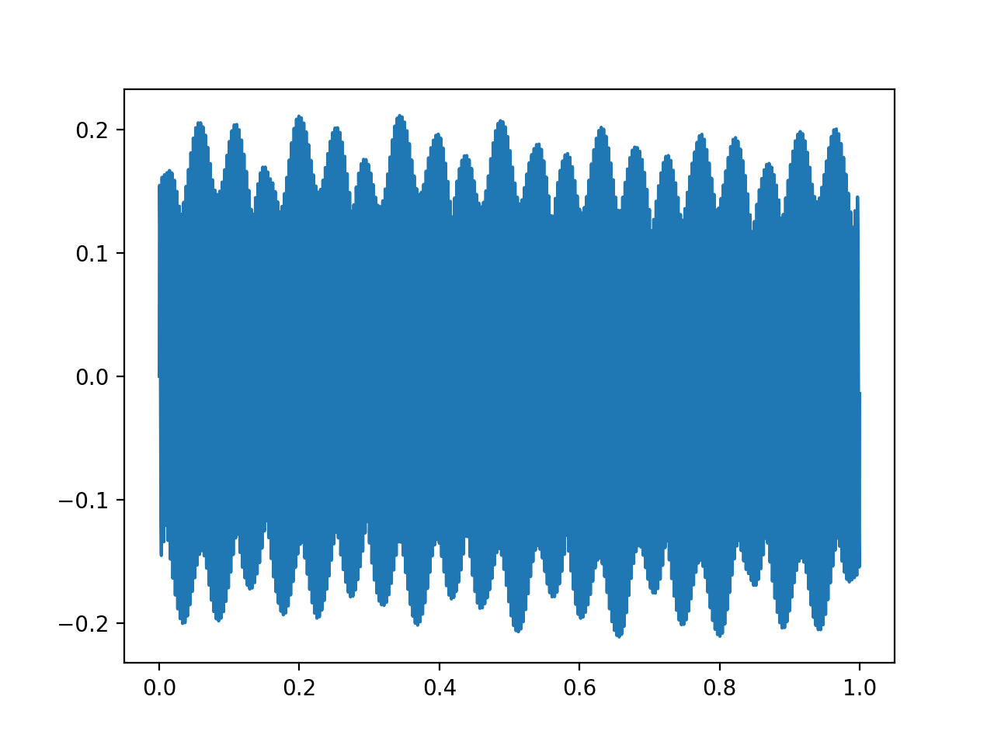

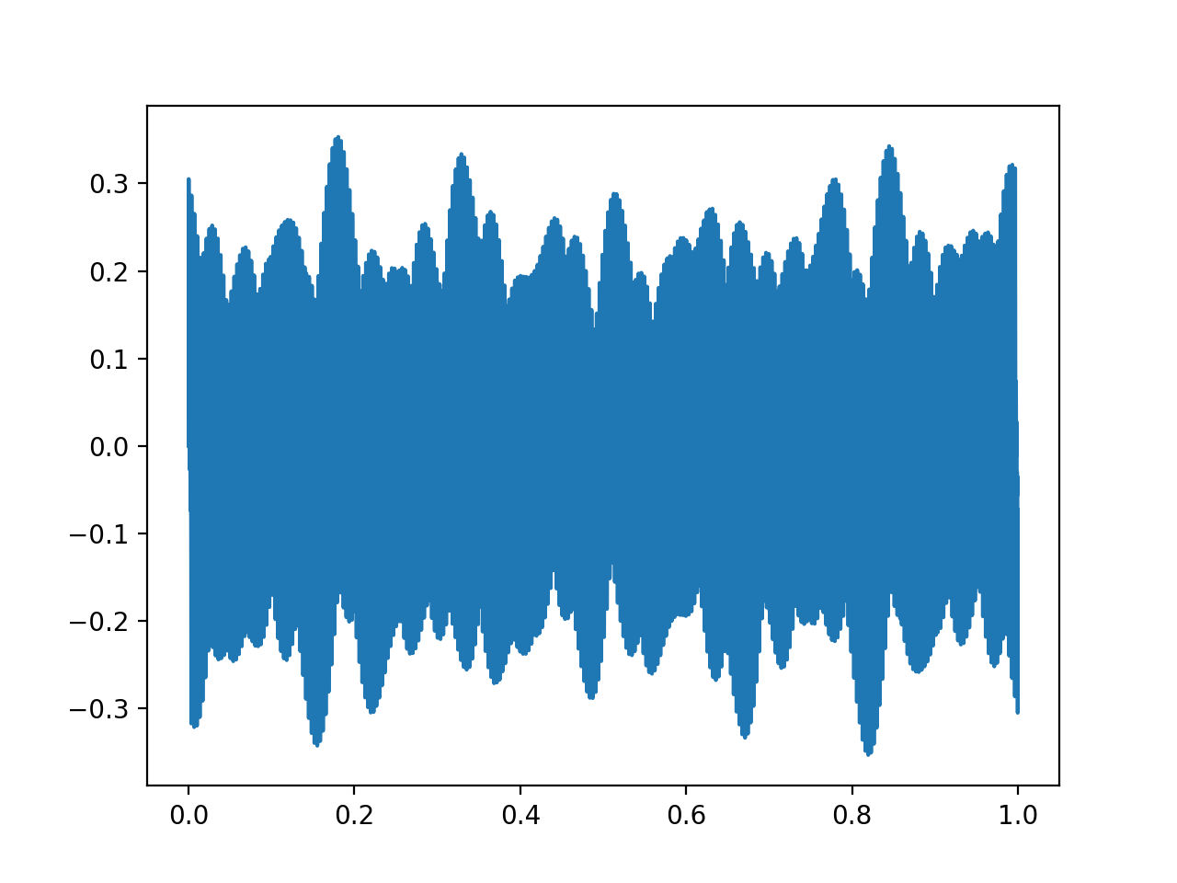

Part 3

Question5:

Part – 1

Use the helping function provided in the file to read and write the audio file.

Code:

**import** numpy **as** np  
**import** matplotlib.pyplot **as** plt  
**import** scipy.fftpack  
**import** math  
**import** mir  
**from** mir **import** Sinusoid  
**from** mir **import** Signal  
  
sig = Signal()  
*#Read audio File*sig.wav_read(**'2.wav'**)  
wave = sig.data  
wavefft = np.fft.ifft(wave)  
*#Writing the audio file*sig.wav_write(**'3.wav'**)

Input Audio –

Output Audio -